AI Assisted Coding
Assginment-3.1
Name : Omprakash Mallepula
Batch No : 39
HT No : 2303A52057
Question 1: Zero-Shot Prompting (Palindrome Number Program)
Write a zero-shot prompt (without providing any examples) to generate
a Python function that checks whether a given number is a palindrome.
Task:
• Record the AI-generated code.
• Test the code with multiple inputs.
• Identify any logical errors or missing edge-case handling.
Prompt : #“Write a Python program that takes a number as user input and checks whether it is a palindrome number.”
Code:
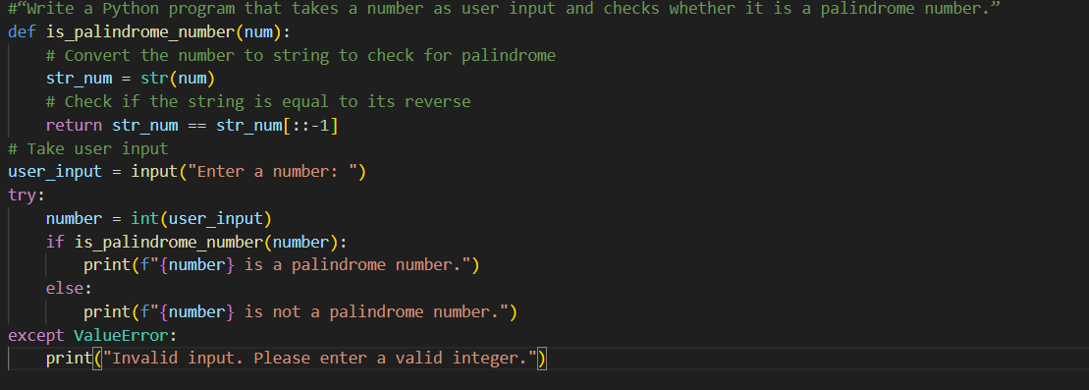
Output:
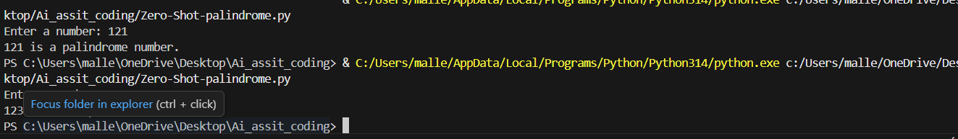
Analysis:
- The zero-shot prompt generated correct basic logic for palindrome checking.
- The initial solution lacked proper handling for negative and invalid inputs.
- Additional validation was required to make the program more reliable.

Question 2: One-Shot Prompting (Factorial Calculation)
Write a one-shot prompt by providing one input-output example and
ask the AI to generate a Python function to compute the factorial of a
given number.
Example:
Input: 5 → Output: 120
Task:
• Compare the generated code with a zero-shot solution.
• Examine improvements in clarity and correctness.
Prompt :
#“Write a Python program to compute the factorial of a number taken as user input.
Code :
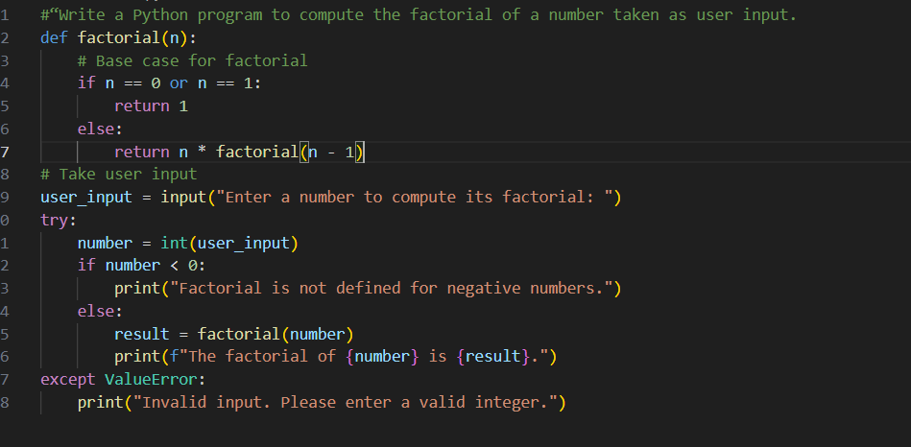
OUPUT :
Analysis :
1. Providing one example improved the clarity of the generated code.
2. The program correctly handled negative numbers compared to zero-shot prompting.
3. The logic was more structured and easier to understand.

Question 3: Few-Shot Prompting (Armstrong Number Check)
Write a few-shot prompt by providing multiple input-output examples
to guide the AI in generating a Python function to check whether a
given number is an Armstrong number.
Examples:
• Input: 153 → Output: Armstrong Number
• Input: 370 → Output: Armstrong Number
• Input: 123 → Output: Not an Armstrong Number
Task:
• Analyze how multiple examples influence code structure and
accuracy.
• Test the function with boundary values and invalid inputs.
Prompt :
#“Write a Python program to check whether a number is an Armstrong number using user input.
Code :
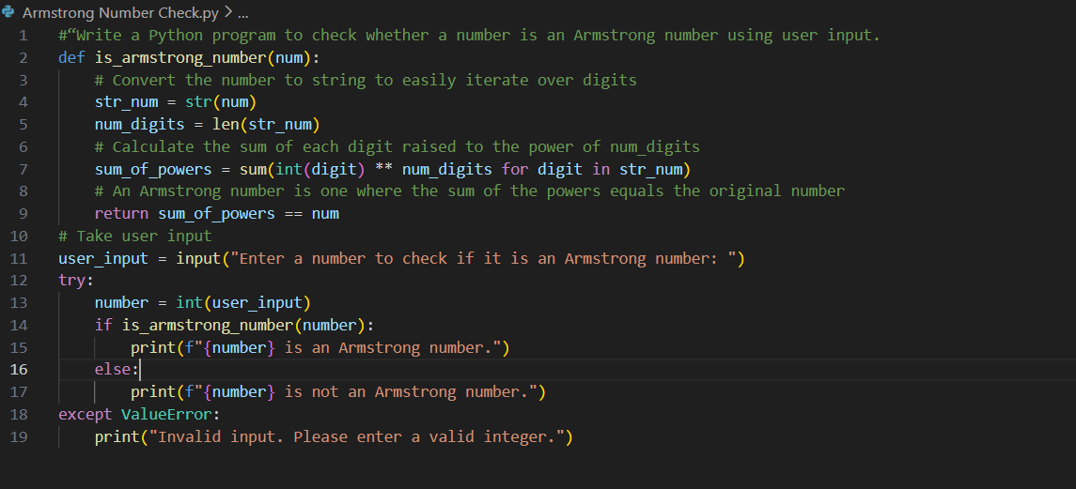
OUTPUT :
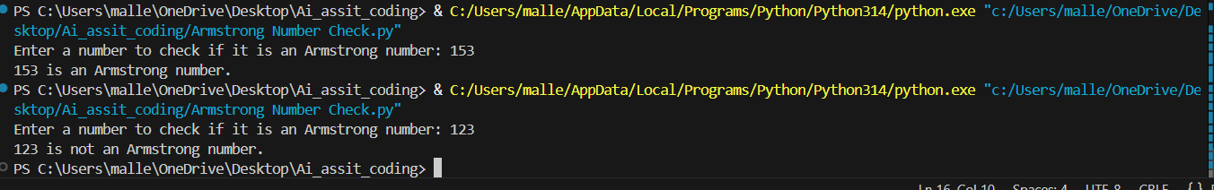
Analysis :
- Multiple examples helped the AI identify the Armstrong number pattern accurately.
- The generated code was well-structured and produced correct results.
- Few-shot prompting reduced ambiguity compared to zero-shot prompting.
Question 4: Context-Managed Prompting (Optimized Number
Classification)
Design a context-managed prompt with clear instructions and
constraints to generate an optimized Python program that classifies a
number as prime, composite, or neither.
Task:
• Ensure proper input validation.
• Optimize the logic for efficiency.
• Compare the output with earlier prompting strategies.
Prompt :
#“Write an optimized Python program that takes a number as user input and classifies it as Prime, Composite, or Neither.
Code :
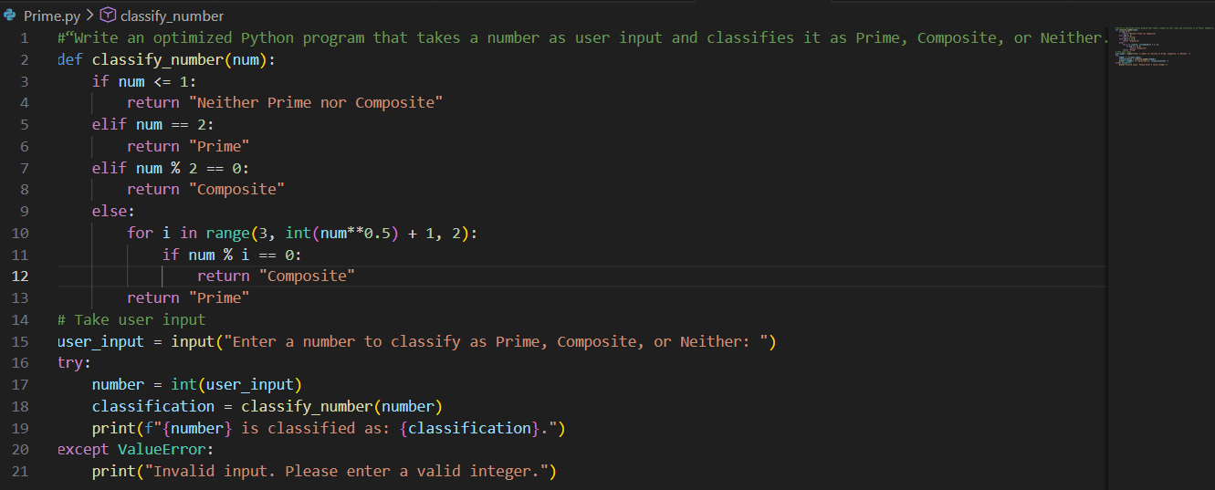
OUTPUT :
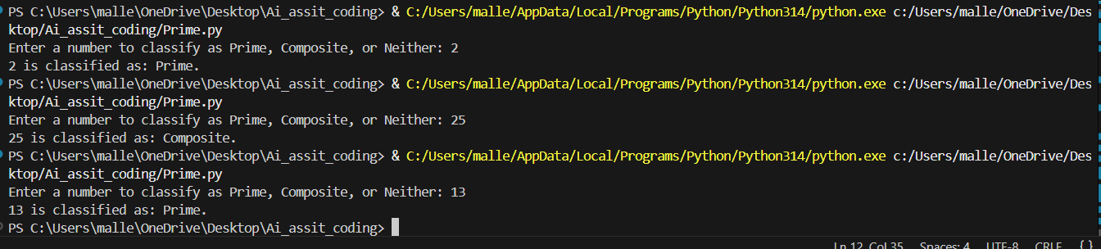
Analysis :
- Clear instructions and constraints resulted in an optimized solution.
- The program efficiently classified numbers using minimal iterations.
- Proper input validation improved program reliability.
Question 5: Zero-Shot Prompting (Perfect Number Check)
Write a zero-shot prompt (without providing any examples) to
generate a Python function that checks whether a given number is a
perfect number.
Task:
• Record the AI-generated code.
• Test the program with multiple inputs.
• Identify any missing conditions or inefficiencies in the logic.
Prompt :
#“Write a Python program that takes a number as user input and checks whether it is a perfect number.”
Code :
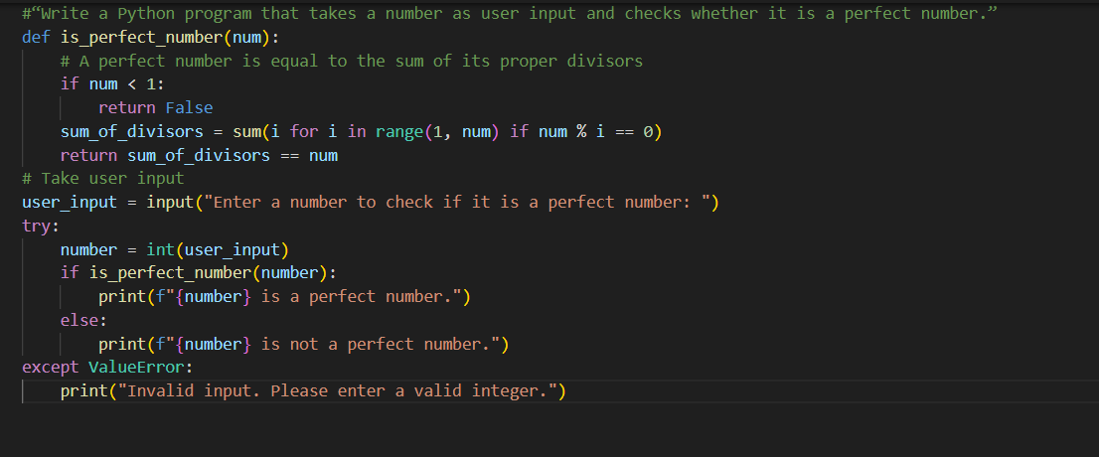
OUTPUT :
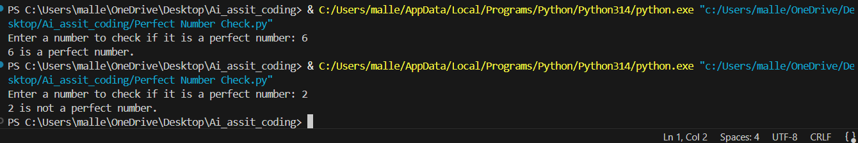
Analysis :
1. The generated code correctly identified perfect numbers.
2. The solution was inefficient for large inputs due to unnecessary iterations.
3. Edge-case handling and optimization were missing initially.

Question 6: Few-Shot Prompting (Even or Odd Classification with
Validation)
Write a few-shot prompt by providing multiple input-output
examples to guide the AI in generating a Python program that
determines whether a given number is even or odd, including proper
input validation.
Examples:
• Input: 8 → Output: Even
• Input: 15 → Output: Odd
• Input: 0 → Output: Even
Task:
• Analyze how examples improve input handling and output
clarity.
• Test the program with negative numbers and non-integer inputs.
Prompt :
#“Write a Python program that determines whether a number is even or odd using user input with proper validation.
Code :
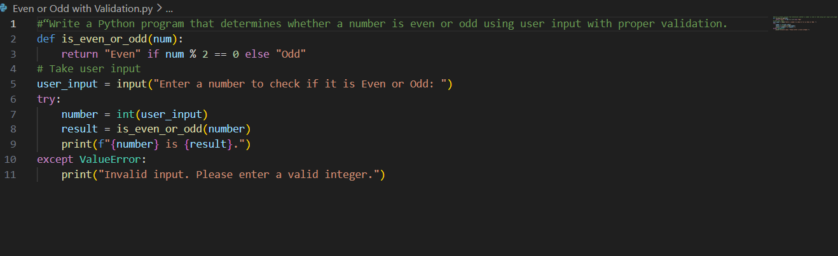
OUTPUT :
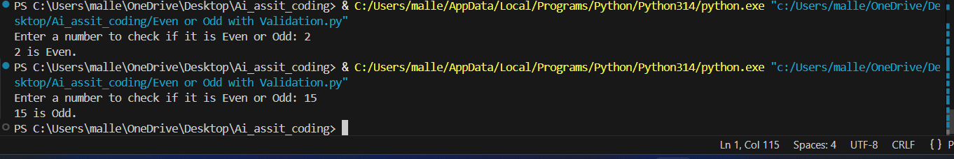
Analysis :
1. Examples improved input handling and output clarity.
2. The program correctly handled negative numbers and zero.
3. Input validation prevented errors for non-integer values.

